**SUSD Resources for Staff supporting LGBT+ Students:**

**Resources for Staff for Gender Support Plans (GSP):**

Powerpoint overview for the GSP process and forms (google drive)

<https://drive.google.com/file/d/1aETXrIArdkfhQ5_nZm1J5fFrL2NzFYax/view?usp=sharing>

Procedures for supporting transgender student (Admin Handbook)

<https://www.stocktonusd.net/cms/lib/CA01902791/Centricity/domain/162/administrative%20handbook/procedures/3.92.1_Transgender_Procedures.pdf>

Gender Support Plan Form (Admin Handbook)

<https://www.stocktonusd.net/cms/lib/CA01902791/Centricity/domain/162/administrative%20handbook/procedures/3.92.2_Gender_Support_Plan.pdf>

Data Request Change Form (Admin Handbook)

<https://www.stocktonusd.net/cms/lib/CA01902791/Centricity/domain/162/administrative%20handbook/procedures/3.93.3_Transgender_DataReqChange.pdf>

Gender Spectrum (Website) – has videos, resources and guidance for best practices in schools

<https://www.genderspectrum.org/articles/educator-resources>

Resources on CDE webpage

<https://www.cde.ca.gov/pd/ee/supportlgbtq.asp>

Schools in Transition Report by ACLU, HRC, NEA, and Gender Spectrum

<https://www.aclu.org/report/schools-transition>

**For support please contact:**

School Counseling Program Specialists can assist you, SCPS Jennifer Robles at ext. 2617 or administrators may reach out to Student Support Services Director, Maryann Santella.

For Gender Support plans, you may invite (not required) Jennifer Robles. Please provide Francine Baird with copies of all Gender Support Plans for district records. Make sure site copies of Gender Support Plans are filed in a confidential file in the principal’s office.

|  |  |  |
| --- | --- | --- |
| Dr. Francine Baird  Assistant Superintendent  Student Support Services  Stockton Unified School District  56 S. Lincoln St.  Stockton, CA 95203  [fbaird@stocktonusd.net](mailto:fbaird@stocktonusd.net)  (209) 933-7470 | Maryann Santella  Interim Director of Student Support Services  Stockton Unified School District  56 S. Lincoln St.  Stockton, CA 95203  [msantella@stocktonusd.net](mailto:msantella@stocktonusd.net)  (209) 933-7130 Ext. 2612 | Jennifer Robles  School Counseling Program Specialist, Student Support Services  Stockton Unified School District  1141 Lever Blvd. Room 105  Stockton, CA 95206  [jrobles@stocktonusd.net](mailto:jrobles@stocktonusd.net)  (209) 933-7130 Ext. 2617 |

**Professional Development:**

We have a series of mini-PD’s that were developed by local partner San Joaquin Pride Center. They are at this link on the SUSD website (on the Student Support Services page under “District Level Resources”. You must log in at the top under “User Options” to be able to access these videos. <https://www.stocktonusd.net/Page/13595>

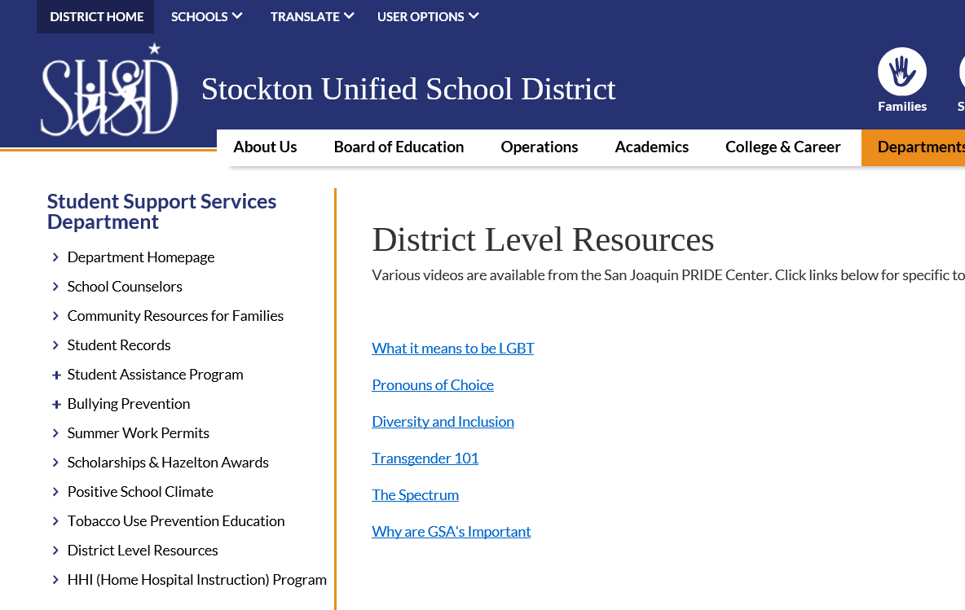

**Resources for Staff on Inlcusive and Supportive Classrooms/Schools and LGBT+ Clubs**

SUSD Website – padlet on Metal Health Department Webpage

<https://www.stocktonusd.net/Page/15380>

SUSD Google Drive - Support posters, school safety, class lessons, professional development resources, book lists, folder with laws and reports with best practices and guidance for schools

<https://drive.google.com/drive/folders/1t5-q28iUEAUb06PjmzIhZMGx1BLrAUrK?usp=sharing>

or <http://bit.ly/SUSDLGBTQResources>

[Kinder FutureExternal link opens in new window or tab.](https://www.kinderfuture.org/)  
The focus of their work is to increase engagement, equity, educational outcomes and safety among LGBTQ youth and their families.

[ONE Archives FoundationExternal link opens in new window or tab.](https://www.onearchives.org/education/)  
The foundation’s goal is to ensure that LGBTQ history is visible and accessible to kindergarten through grade twelve (K –12) students and educators through free and low-cost resources.

[Teaching LGBTQ HistoryExternal link opens in new window or tab.](http://www.lgbtqhistory.org/)  
This website provides resources and lesson plans for teaching LGBTQ history and fulfilling the requirements of the Forced Arbitration Injustice Repeal Act (FAIR Act).

**SUSD Resources for supporting LGBT+ Students:**

**Resources for Students and Student Clubs/Activities**

[Genders & Sexualities Alliance (GSA) NetworkExternal link opens in new window or tab.](https://gsanetwork.org/)  
school-based GSA clubs through peer support, leadership development, and community organizing and advocacy. Our youth leadership development model supports youth in starting, strengthening and sustaining GSA clubs to create school communities where all students can be safe from discrimination, harassment, and violence based on their sexual orientation or gender identity.

[Gay Lesbian Straight Educator Network (GLSEN)External link opens in new window or tab.](https://www.glsen.org/)  
activating supportive educators, they believe in centering and uplifting student-led movements, which have powered initiatives like the Day of Silence, Ally Week, and more.

In the community, there is the San Joaquin Pride Center, that offers support for school based GSA clubs as well as community based youth support and activities. Their website is sjpridecenter.com and their phone number is (209) 565-5023.

**Resources for Families**

If students or families are in need of support or resources, the first stop is the School Administrator and School Counselor. If the School Admin or Counselor need support, they can consult with their School Counseling Program Specialist or Jennifer Robles in Student Services.

Our Mental Health Services department has a clinician with expertise in supporting the LGBT community, Amanda Munoz. MH has created a padlet with resources for students and families and also resources for teachers. <https://www.stocktonusd.net/Page/15380>

In the community, there is the San Joaquin Pride Center, that offers services, supports, and activities for LGBT youth and families. Their website is sjpridecenter.com and their phone number is (209) 565-5023.

The Trevor Project offers 24 Hour Assistance for LGBTQ youth 1-866/488.7386 or Text "START" to 678678   [www.thetrevorproject.org](http://www.thetrevorproject.org/)

The Family Acceptance Project out of San Francisco State University has wonderful resources for families including posters, booklets, and videos in various languages and designed for different cultural groups. <https://familyproject.sfsu.edu/>

Gender Spectrum – online library of resources for schools, youth, and families

<https://www.genderspectrum.org/articles/educator-resources>

Trans Lifeline – organization that connects trans people to community, support, and resources.

[www.translifeline.org](http://www.translifeline.org/)

PFLAG – Parents and Friends of Lesbians and Gays is a national parent support group. The closest chapter is in Sacramento but they have a website with resources at pflag.org .